**Assignment -2**

|  |  |
| --- | --- |
| Assignment Date | 26 September 2022 |
| Student Name | SNEKHA.A |
| Student Roll Number | 113219041112 |
| Maximum Marks | 2 Marks |

Question-1

**Pharma Sales Dashboard**

Description:- Sales of Pharmaceutical products, which may include medicines, surgical

devices, consumables of any form, machines, and equipment used in surgeries are called

Pharma Sales. The target audience is doctors of any kind, chemists, and/or purchase in charge

in hospitals or pharmacies.

**Challenge:- Upload the dataset to CognosAnalytics, prepare the data, explore and Create Interactive dashboard :**

Task 1:Sales By Customer.

Task 2:Sales By Location.

Task 3:Sales By Sales Representative.

Task 4: Received Inventory From Supplier

Task 5: Inventory Stock for Warehouse Locations

Task 6: Sales Trend

Task 7:Monthly Sales

Task 8: Actual and Received Inventory by Month

ANSWERS:(Task1-Task4)

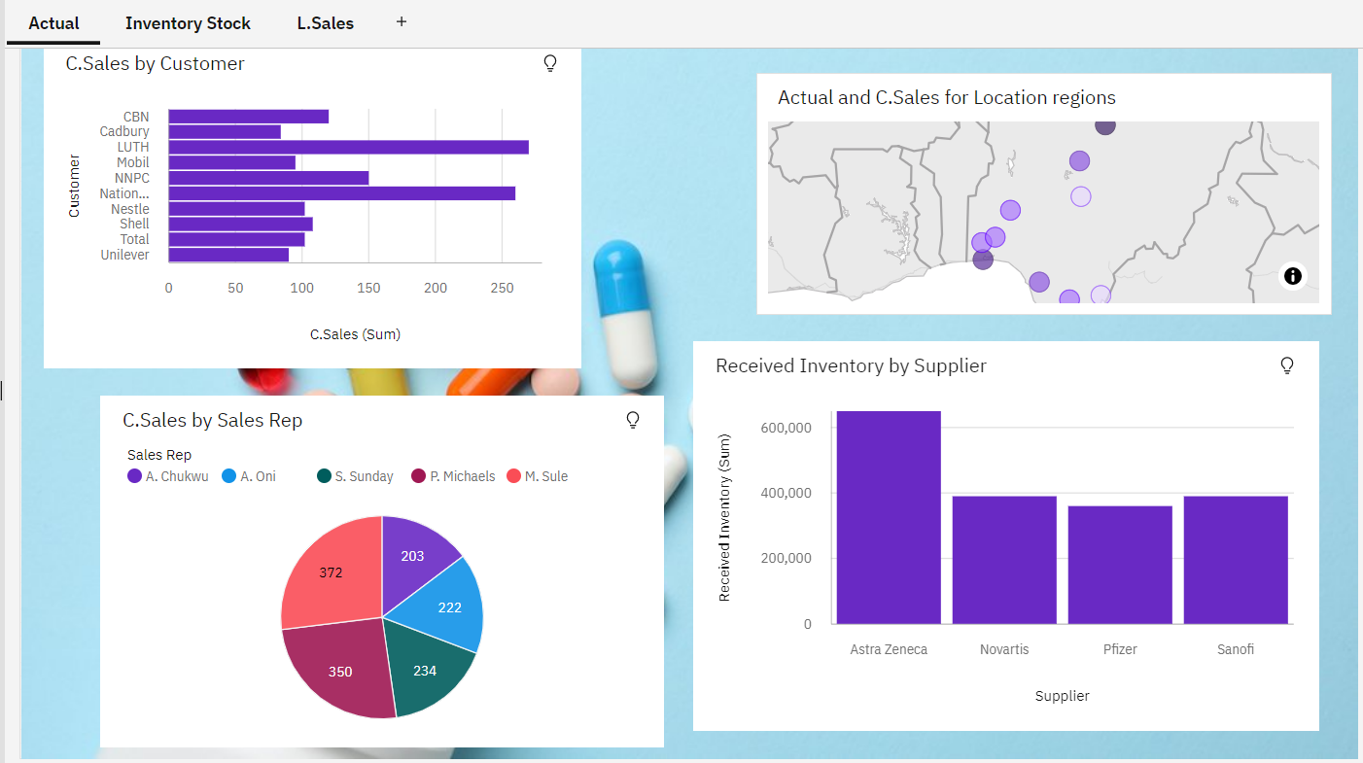

ANSWERS FOR (TASK5-TASK 8):

